Develop a VB project to display the odd and even numbers in given range
Form design:
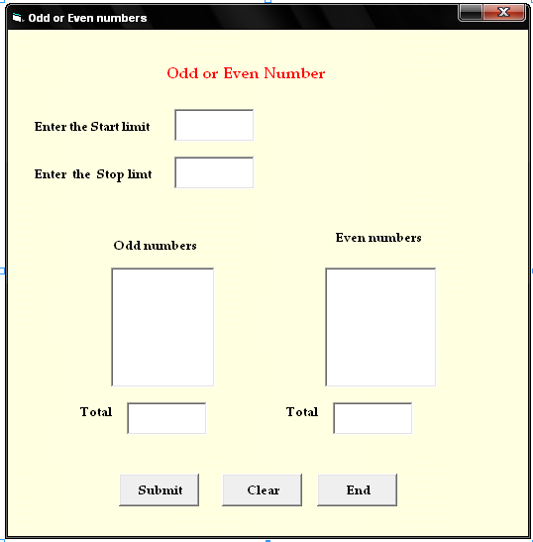

Properties

Control | Name | Caption
Text1 | Text1
Text2 | Text2
Command1 | Cmdsubmit | Submit
Command2 | Cmdclear | Clear
Command3 | Cmdend | End

3.Odd or Even numbers
Aim:
To develop a VB project to display the odd and even numbers in given range

Coding:
Private Sub cmdsubmit_Click()
Dim a, b, c, d, e, i As Integer
a = Val(Text1.Text)
b = Val(Text2.Text)
d = 0
e = 0
For i = a To b
c = i Mod 2
If c = 0 Then
List2.AddItem (i)
d = d + 1
Else
List1.AddItem (i)
e = e + 1
End If
Next i
Text3.Text = d
Text4.Text = e
End Sub

Private Sub cmdclear_Click()
Text1.Text = " "
Text2.Text = " "
Text3.Text = " "
Text4.Text = " "
List1.Clear
List2.Clear
End Sub

Private Sub cmdend_Click()
End
End Sub

Output:

